**Ekshiksha**



Ekalavya Summer Internship2017

Submitted in fulfilment of internship project

By

-Ekshiksha Physics Team

Under the Guidance of

Prof. D. B.Phatak

Department of Computer Science and Engineering

Indian Institute of Technology, Bombay

Mumbai

**Project Report Approval**

**Team Members:**

1. Akshit Soni
2. Anupam Singhal
3. Harish Yadav
4. Narendra Chintala
5. Pragati Chougula
6. Reshab Sharma
7. Sachin Chand
8. Somya Gupta
9. Snehal Gharat

________________________

(Mr. Rajnikant Jangir)

**Technical Mentor**

________________________ ________________________

(Mr. Avinash Awate) (Prof. (Dr.) Deepak B. Phatak)

**Supervisor Guide**

Date: 05-July-2017

**Place: IIT Bombay**

**Acknowledgement**

It is our privilege to express our sincerest regards and deep gratitude to all those who have helped us complete our project successfully. It is the result of collective efforts of coordinators, mentors and all the team members.

We deeply express our sincere thanks to **Prof. D.B. Phatak** for selecting us and allowing us to work on the project **“Ekshiksha”**. His constant impetus and motivation has helped us evolve better.

We would like to express deep gratitude to our project mentors, **Mr. Avinash Awate** and **Mr. Rajnikant Jangir**, for their valuable inputs, guidance, encouragement, whole-hearted cooperation and constructive criticism throughout the duration of our project. Their consistent efforts and guidance have helped us develop a deep insight and understanding of various concepts.

We would also like to thank **Mr. Rahul Kharat** and **Mr. Bikas Chhatri** for making our stay here comfortable and for all their administrative help. Without their mention our project would always have been incomplete.

Lastly, we whole heartedly thank all our other colleagues and fellow interns for helping us with their critical advice and support.

**Abstract**

“Physics 3D animation creator" -is an EKSHIKSHA IIT BOMBAY project aimed to develop a platform for teaching physics to the students by means of animations, thus making the learning process more interactive and fun for them.

The model developed by us aims at providing a framework where interactive physics experiments can be performed .The user can create animations and interact with it in many ways to get a good grasp of the concept The various subcategories of physics like mechanics, optics, electricity etc are covered and our software provides the flexibility to the user to choose any category and perform interactive experiments in that category.

This platform can even be used by teachers to make new objects and animation, thereby providing a flexible methodology for teaching. The framework developed under this project can run on any platform having good Internet connection.

TABLE OF CONTENTS

**Chapter 1**

**INTRODUCTION**

**1.1 Overview of Traditional way to learn Physics**

For any student to learn physics, they need to learn from books and require a labrotory to learn physics practically. Today many schools in India, due to lack of fund don’t have physics laboratory so students are not able to perform the experiments. Thus, limiting their practical knowledge. With advancement of technology, today we can view the physics concepts visually by watching videos.

**1.2 Purpose**

Researches have always proved that visual resources make the learning process easier and quicker, so we made the inclusion of animation in our application, a prime target. Ekshiksha Physics provides an interactive platform for students to learn physics concepts by performing experiments online. Students can interactively perform experiments without need of physical equipments. This provides a collaborative and efficient way of learning. Students can use this platform to learn concepts anytime, anywhere.

**1.3 Scope**

The target audience of our application is not limited to any particular age group or domain of students instead it extends to all the learners irrespective of their age group and learning domain. To enhance the reach and scope of this application, it is made available online, thus can be used on any system having a good internet connection, without any special hardware or software requirements.

Thus the Ekshiksha Physics, by virtue of its simplicity and extended scope, can be of great educational importance.

**Chapter 2**

**Technologies Used**

* **Three.js** is a cross-browser JavaScript library/API used to create and display animated 3D computer graphics in a web browser.
* **MySQL** - It is the world’s most used open source relational database management that runs as a server providing multi-user access to a number of

databases.

* **Apache Tomcat server** - It is the most popular Web server open source software for hosting java applications. It enables a computer to host one or more websites that can be accessed over the Internet using a Web browser.
* **Javascript** -JavaScript (JS) is a programming language mostly used client-side to dynamically script webpages.
* **Java** – We have used java as server side scripting language for creating servlets and for making connections with database (JDBC).

**Chapter 3**

**Design**

**Use Case for login module**

|  |  |
| --- | --- |
| **USE CASE** | **DESCRIPTION** |
| Register | The new user must register once to create account. |
| Login | The registered user must enter his username and password to access their accounts. |
| Forgot details | If a user forgets his login details then he can click on forgot details button which will guide him to recover the details. |

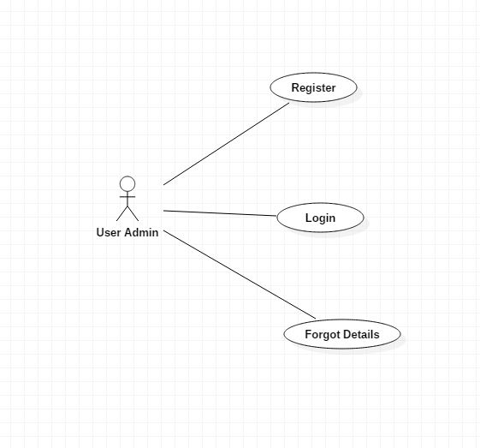

Fig no. 3.1 :- Use case diagram for all users(common paths)

**Use Case for overall framework**

|  |  |
| --- | --- |
| **USE CASE** | **DESCRIPTION** |
| Select topic | The user must select one physics topic to move further |
| Give Basic Details | The user is supposed to give basic details of experiments like experiment name and author name. |
| Change Theme | The user can change themes of the scene from this menu. |
| Choose Objects | The user can choose different objects by dragging them in the scene for animation. |
| Modify Object Attributes | The user can change object attributes like its color, size, etc. by clicking on that object. |
| Add Animation | The user can animate the objects that are dragged in the scene. |
| Add Objects | The user can add new objects to the list. |
| Concept / Theory editor | The user can write details about the experiments. |
| Save Progress | The user can save the animation done. |

**Overall Use case diagram :**

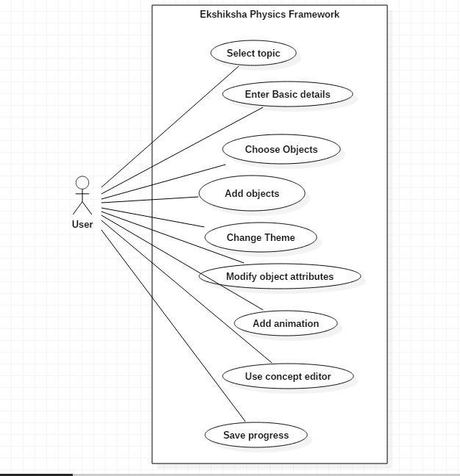

Fig 4.2:- Overall use case diagram

**Chapter 4**

**List of 3D objects included in the project**

Mechanics

* cuboid
* sphere
* cone
* cylinder
* wedge
* Spring
* Cart
* Pulley
* Weighing machine
* Supporting stand

Optics

* Convex mirror
* Concave mirror
* Convex lens
* Concave lens
* Prism

Electricity

* Ammeter
* Led
* Bulb
* Battery
* Resistor
* Switch
* voltmeter

**CHAPTER 5**

**GRAPHICAL USER INTERFACE**

5.1 Home page

This is the homepage of Ekshiksha physics, it has following options – Electricity, Mechanics and Optics. The user can select any category and start experimenting.

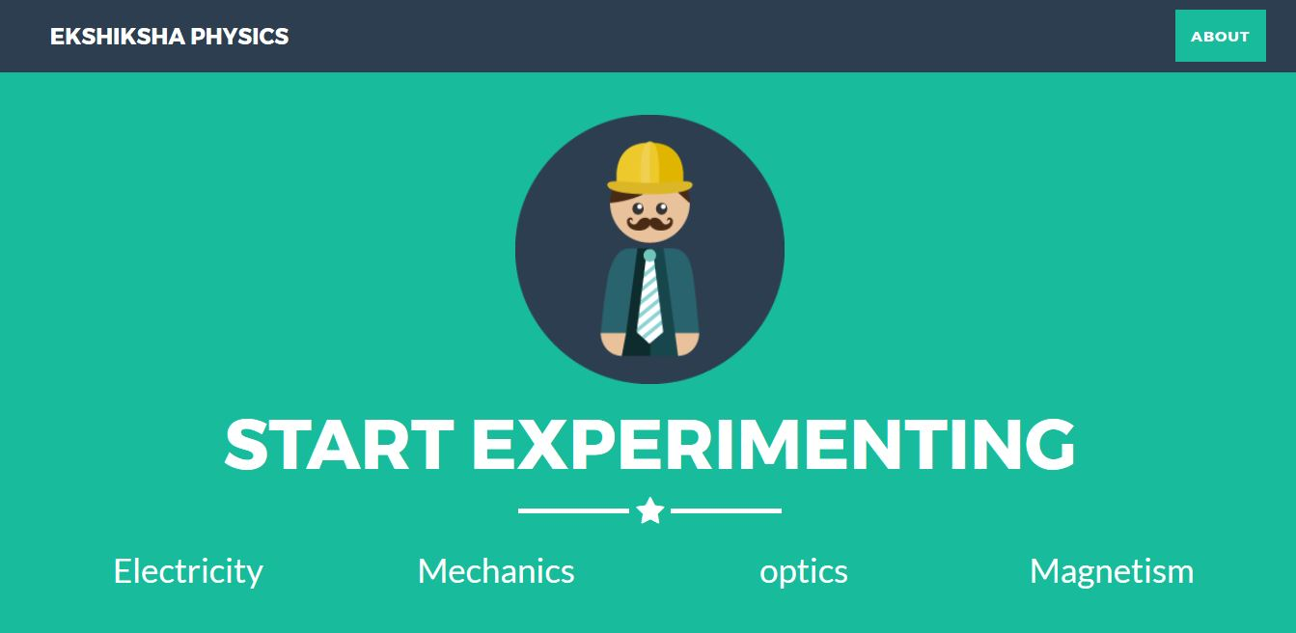

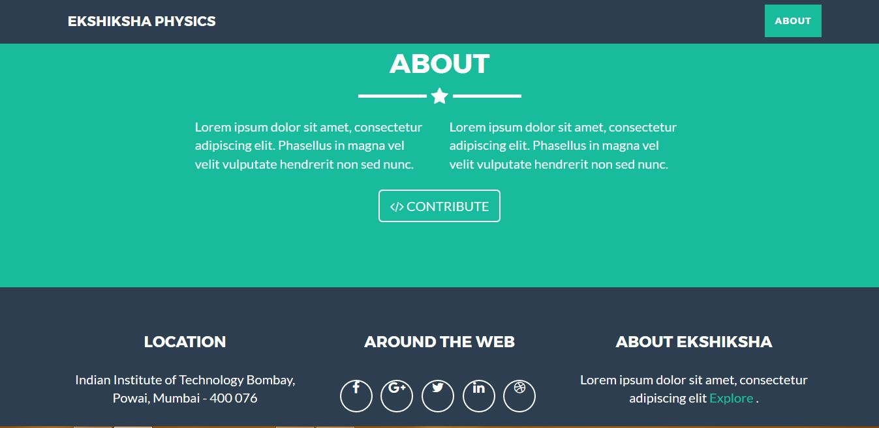

5.2 MAIN SCREEN

This default screen will be displayed after the user selects a category from the homepage. It has a vertical side menu from which user can select any option.

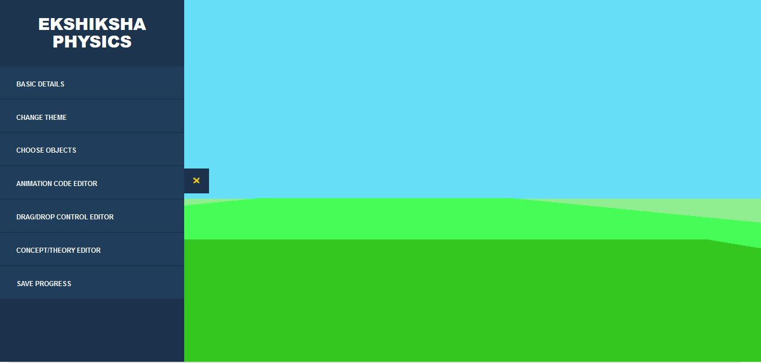

5.3 BASIC DETAILS PANEL

This panel is displayed when user selects the “BASIC DETAILS” option from the vertical side menu. The user has to enter the basic information of experiment like:

1. Experiment name
2. Author name

After clicking on the submit button, the details will be stored in the “exp_details” table of the “physics” database.

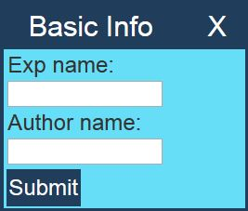

5.4 CHANGE THEME OPTION

This panel contains different background themes. The user can select any theme of his choice and the background of the main theme is changed.

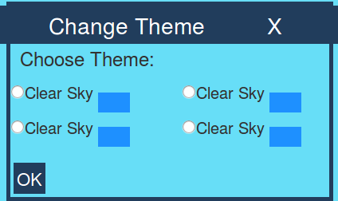

5.5 CHOOSE OBJECTS FROM SIDE PANEL

This panel is displayed when user selects the “Choose objects” option from the vertical side menu. It contains objects of the corresponding category choosen by the user.

5.5.1 MECHANICS

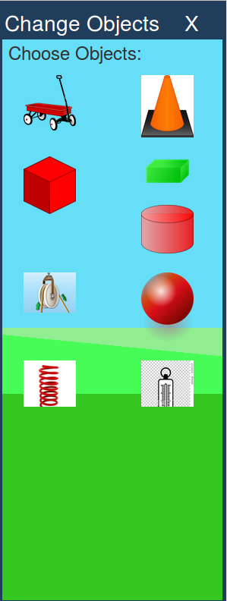If the user has selected mechanics category then the following panel will be displayed in the right side of the window.

4.6 ADD NEW OBJECT WINDOW

Chapter 6

Result and Conclusion

Chapter 7

Future Work